Acute neck pain
We acknowledge Mayfield Clinic for the following information.

Overview
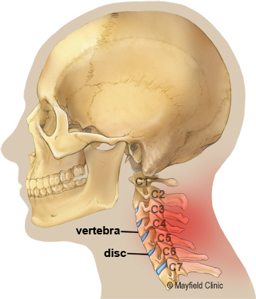
Neck pain results when the spine is stressed by injury, disease, wear and tear, or poor body mechanics. Acute neck pain is abrupt, intense pain that can radiate to the head, shoulders, arms, or hands. It typically subsides within days or weeks with rest, physical therapy, and other self-care measures. You play an important part in the prevention, treatment, and recovery process of neck pain. However, if chronic, pain will persist despite treatment and need further evaluation.

Figure 1. (side view) The neck region is called the cervical spine. Protected within the bones of the cervical spine are the spinal cord and nerves. The seven cervical bones (vertebrae) are numbered C1 to C7. Each bone is separated and cushioned by shock-absorbing discs. The spinal nerves pass through bony canals to branch out to the neck and arms.

Types of neck pain
With the most range of motion, the cervical spine can be prone to overuse and injury (Fig. 1). Neck pain ranges from mild to severe, depending on the amount of injury, and can be acute or chronic.
Acute neck pain occurs suddenly and usually heals within several days to weeks. The source of pain is usually in the muscles and ligaments, joints, or discs.
Chronic neck pain persists for more than 3 months; it may be felt all the time or worsen with certain activities. Although its source may be hard to determine, contributing factors include nerve damage, tissue scarring and arthritis. Chronic pain sufferers should seek advice regarding pain relief management, self-help, and lifestyle improvement.

What are the symptoms?
The signs and symptoms of neck pain may be stiffness, tightness, aching, burning, or stabbing or shooting pains, pressure, or tingling. Muscles can feel sore or tense in the neck, face, or shoulders. Muscles can spasm when they go into a state of extreme contraction (e.g., after whiplash). Movement may be restricted – perhaps you cannot turn your head. If nerves are involved, pain, tingling, numbness, or weakness may develop in your shoulders, arms, or hands. Referred pains into the head, arms, and face may also occur, including vertigo, headaches, facial neuralgia, and muscle weakness.
Several situations signal the need for prompt medical attention. If nerve compression is severe, symptoms can include pain, numbness, tingling in the arms or legs, loss of bladder or bowel control, or loss of strength and problems with co-ordination.
Neck pain along with a severe headache, fever, or nausea could be a sign of infection or a bleed in the brain. If your neck is so stiff that you cannot touch your chin to chest, seek medical attention immediately.

What are the causes?
Neck pain can result from head trauma (e.g., motor vehicle accident), injury, poor posture, stress, natural wear, disease, and repetitive activities. Poor spinal alignment (e.g., slouching, sleeping on the stomach) and improper lifting stress the cervical spine and make injuries more likely. Neck pain can result from:
- Injury or trauma: A whiplash injury, sports injury, or fall can strain or tear muscles and ligaments. Fractures can occur.
- Bulging or herniated disc: The gel-like centre of a spinal disc can bulge or rupture through a weak area in the wall and compress nerves.
- Pinched nerve: Compression of a spinal nerve as it leaves the canal can cause pain to travel down the arm into the hands or fingers. Pinched nerve pain differs from carpal tunnel syndrome, which usually involves numbness.
- Osteoarthritis (degenerative disc disease): As disc naturally age, they dry out and shrink; bone spurs can form. These changes lead to stenosis or disc herniation.
- Stenosis: Narrowing of the bony canals in the spine can compress the cord and nerves, causing them to swell and inflame.

How is a diagnosis made?
A careful medical exam will help determine the type and cause of your neck problem, and the best treatment options. A diagnostic evaluation includes a medical history and physical exam. Sometimes imaging scans e.g. x-ray, MRI, and tests to check your muscle strength and the nervous system, including your reflexes are used.

What treatments are available?
Healing begins with self-care and nonsurgical strategies (Fig.2). The goal is to correct the problem, restore function, prevent re-injury, and improve your lifestyle and ability to participate in the activities you are interested in, or were previously involved with.
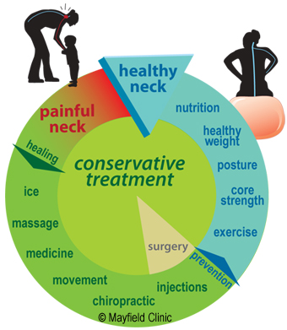

Figure 2. Exercise, strengthening, stretching and ideal weight loss are key elements to your treatment.
Self-care: Neck pain often resolves with rest, ice or heat, massage, pain relievers, and gentle stretches. To reduce muscle inflammation and pain, use an ice pack for 20 minutes several times a day during the first 48 to 72 hours. Thereafter, a warm shower or heating pad on a low setting may be added to relax the muscles. A short period of bed rest is okay, but more than a couple of days does more harm than good. If self-care treatments are not working within the first couple of days, see your chiropractor.
Medication: Many people get pain relief with over-the-counter nonsteroidal anti-inflammatory drugs (NSAIDs) such as aspirin, ibuprofen, or naproxen. A muscle relaxant may be prescribed for the spasms. If pain is severe, an analgesic may be prescribed that can be taken with the NSAID or muscle relaxant.
Steroids can reduce the swelling and inflammation of the nerves. Steroids can be taken orally or by direct injection and may provide pain relief within 24 hours.
Chiropractic therapies/exercise: Chiropractic care can help you return to full activity as soon as possible and prevent re-injury. They can show proper lifting and walking techniques, and exercises to strengthen and stretch your neck, arms, and abdominal muscles. Massage, ultrasound, heat, and traction may also be recommended for short periods.
Surgery: Surgery is rarely needed unless you have muscle weakness, a proven disc herniation, cervical cord compression, problems with balance and coordination, or severe pain that does not resolve after a reasonable course of nonsurgical treatment.

Recovery and prevention
Most people with acute neck pain respond rapidly to treatment; 80% are symptom-free within 1 to 2 weeks. A positive attitude, regular activity, and a prompt return to work are all very important elements of recovery. If regular job duties cannot be performed initially, modified (light or restricted) duty may be suggested for a limited time.
Prevention is key to avoiding recurrence:
- Proper lifting techniques
- Good posture during sitting, standing, moving, and sleeping
- Regular exercise with stretching and strengthening
- An ergonomic work area
- Good nutrition, healthy weight, lean body mass
- Stress management and relaxation techniques
- No smoking

Links
www.spine-health.com (http://www.spine-health.com)
www.spineuniverse.com (http://www.spineuniverse.com)
Glossary
Acute: a condition of quick onset lasting a short time, opposite of chronic.
Arthritis: joint inflammation caused by infection, immune deficiency (rheumatoid arthritis), or degeneration of the cartilage that causes pain, swelling, redness, warmth, and restricted movement.
Chronic: a condition of slow progression and continuing over a long period of time, opposite of acute.
Osteoporosis: loss of bone or atrophy of skeletal tissue that causes bones to weaken and become brittle, and prone to fracture. Preventative measures include adequate calcium and regular exercise to stimulate bone metabolism.
Radiculopathy: refers to any disease affecting the spinal nerve roots. Also used to describe pain along the sciatic nerve that radiates down the leg.
Spinal cord: part of the central nervous system enclosed and protected by the spinal vertebrae; conducts messages (impulses) back and forth between your brain and body to control sensation and movement.
Vertebra (plural vertebrae): 1 of 33 bones that form the spinal column. From top to bottom, there are 7 cervical, 12 thoracic, 5 lumbar, 5 sacral, and 4 coccygeal vertebrae. The top 24 bones are moveable.

Mayfield Certified Health info materials are written and developed by the Mayfield Clinic. We comply with the HONcode standard for trustworthy health information. This information is not intended to replace the medical advice of your health care provider.

Cannington Chiro Services

Patients attending Cannington Chiro help us by first filling out a “New Patient Questionnaire”, followed by a thorough consultation, examination, and assessment. This helps us help you.
Beginning treatment ASAP is a priority to us, with the aim of, in most cases, commencing treatment from day one. Healing, repair and rehabilitating the body after being injured is a process – and processes take time - so with understanding and patience a positive long-term outcome can be expected.
We look forward to helping you and demonstrating that we may be the missing link in your recovery.

